English 7
Chapter 8-Review C Guided Practice
Name--_____________________
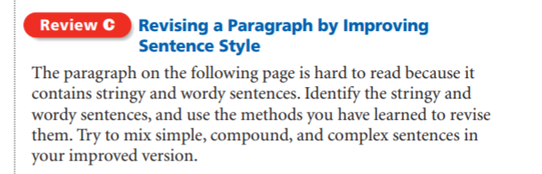

EXAMPLE 1. As a result of what happened when the script was rewritten, the movie is based in fact but contains a lot of events that are not true and have no basis in history.

- Because the script was rewritten, the movie is based in fact but contains a lot of events that are not true.

The movie Anastasia is based on a real story about a real girl from history. Her name was Anastasia Romanov and she was born in 1901 and lived in Russia. The movie is about some historical events in Russia’s history, and many things in the movie are not true. For example, the movie says that Anastasia was eight years old when the revolutionaries came to overthrow and defeat her father, who was the czar, but the real Anastasia was a teenager in real life. The movie shows Anastasia and her grandmother, who was the Grand Duchess Marie, escaping together, but in reality her grandmother was already safely in Denmark when the family was seized and captured. Unlike the character in the movie, the real Anastasia did not get away, her remains were found with her family’s remains when they were found in 1991. Although Anastasia is an interesting movie, people who see it should also know the real story that happened.

